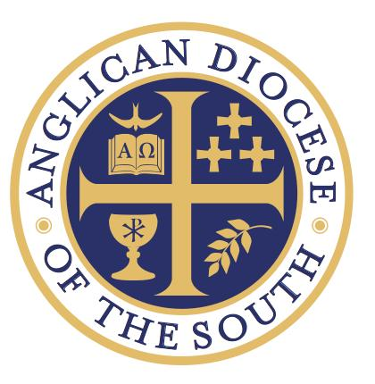
Anglican Diocese of the South
Attn: Canon Sean George
P.O Box 776
Loganville, GA 30052
sean@adots.org

Response Questions |  | For | Presbyter(Priest) Track Vocational Deacon Track
Last Name | First Name |  |  | M.I. | Date

Please provide answers to the following questions. The box is a suggested limit for the length of response for most of the questions below. Additional sheets may be added, but this is not recommended.

- Provide a brief narrative of your spiritual history – focusing on your journey to faith in Jesus Christ. Include those key aspects of your journey that are benchmarks.

- Discuss the role of Scripture in your daily life. Respond to the following passage of Scripture: “To the Jews who had believed him, Jesus said, ‘If you hold to my teaching, you are really my disciples. Then you will know the truth, and the truth will set you free.” (John 8:31-32 NIV)

- How would you describe your call to ministry? Using the Great Commission text (Matthew 28:18-20), please provide your assessment of the call you have received from the Lord. How do you see the Lord using you in ordained ministry to bring many to faith in Jesus Christ?

- Scripture talks specifically about the qualifications for those called to serve as Shepherds. Refer to I Timothy 3, Titus 1, and I Peter 5. Does your life serve as a complement to these passages? List your strengths and weaknesses as a potential shepherd of a church. What areas of growth would be most beneficial for your role as a potential Deacon or Priest?

- In what ways has your calling been confirmed by others; including your Rector, lay people, and/or those outside the church? How are you currently involved in ministry in your local church?

- (For married applicants) – What is your spouse’s attitude toward your seeking ordination? What would you say is the general health of your marriage and the overall health of your family. (Please provide the ages of your children if you have children living at home). If you were to enter the ordination process, would you and your spouse willingly submit to a marital evaluation by a licensed counselor?

- Why have you selected the Anglican Diocese of the South (ADOTS) for ordination? What specifically has made ADOTS the best fit for your ministry and calling? Provide a basic outline of your decision process. Did you consider seeking ordination elsewhere, and if so, why have you been called to the Anglican Diocese of the South?

